# A novel biomechanical approach to infer size-based functional response in aquatic and terrestrial systems

Portalier S.M.J., Cherif M., Fussmann G.F., Loreau M.

**Keywords**: functional response, body size, medium, predator-prey

## 1 Introduction

The network of predator and prey interactions, known as food web, is a fundamental part of all ecosystems. However, our understanding of the structure of food web remains incomplete and is still a challenge in ecology (May, 1999).   
 A growing body of literature emphasized the need to move from single-species studies to multi-species studies. For example, the study of individual species appears not being well-suited for conservation purpose (May, 1999)⁠. A community-based or an ecosystem-based approach would certainly be more convenient (Zabel et al., 2003)⁠.   
 The strength of predation pressure on a prey, the fact that the predator is a generalist or a specialist, directly affects prey persistence and/or life cycle (Hanski et al., 1991)⁠, which in turn may affect the whole ecosystem through trophic cascade. Hence, a better understanding of predator-prey relationship is fundamental for a better understanding of ecosystems.   
 It appears that body size seems to be a good predictor of trophic position (Williams et al., 2010)⁠ and plays a major role in structuring food webs (Cohen et al., 1993)⁠. However, most studies considering body size structure of food webs remain empirical (Gravel et al., 2013)(Barrios-O’Neill et al., 2016)⁠. Thus, a more general approach using concrete traits (i.e., body size) and valid for a wide range of species would allow a better understanding of the size structure of food web.   
 On the other hand, living organisms are constrained by the physical properties of the surrounding medium (Denny, 1993)(Denny, 2016)(Vogel, 1988)(Vogel, 1996)⁠. Physical properties of the medium (i.e., gravity, density and viscosity) affect the way organisms move and interact with each other. Since predation usually implies motion, these factors create mechanical constraints acting on predators (Howland, 1974)(Domenici, 2001)(Domenici et al., 2007)(Domenici et al., 2011a)⁠. These factors are ubiquitous, and their effects are related to size. Hence, incorporating mechanical constraints into models would lead to a better understanding of the size-based relationship between predators and prey, and even of the size-structure of food webs. Considering the link between the physical and the biological world would be a major improvement in our understanding of food web structure (Loreau, 2010)⁠.  
 A first, and essential, step would be to investigate how these factors affect the functional response. Hence, functional response (i.e., the relationship between prey abundance and predator consumption) is known to drive the feasibility of predator-prey interactions and the stability of the whole food web (Brose, 2010)⁠. A better understanding of factors driving the functional response would lead to novel insights on the study of food webs.   
 Since the pioneer work by (Holling, 1961)⁠, several models of functional responses were proposed. These models emphasized different features of predator-prey relationships, such as feeding saturation (DeAngelis et al., 1975)⁠, interference (Beddington, 1975)(Crowley and Martin, 1989)⁠, or interaction between predators (Wasserman et al., 2016)⁠. Moreover, many studies have shown that functional response is strongly affected by the body sizes of predator and prey (Aljetlawi et al., 2004)(Vucic-Pestic et al., 2010)⁠. However, the role played by the physical medium in constraining the functional response remains largely unexplored.  
 Previous studies that considered the surrounding medium usually focused on specific aspects of predation or on specific taxa (Domenici et al., 2011a)(Domenici et al., 2011b)⁠, or investigated specific aspect of the medium such as dimensionality (Pawar et al., 2012)⁠ or complexity (Barrios-O’Neill et al., 2016)⁠. However, the role played by the surrounding medium acting at the individual level on predator-prey relationship, driving the functional response, remains to be explored.  
 In a recent study, (Portalier et al., 2019)⁠ provided a biomechanical model that uses general laws of mechanics and well-known biological laws, all related to body size, to predict predator to prey interactions. This model fits data remarkably well (Portalier et al., 2019)⁠. The model provides a detailed mechanism for predation, where predators have to move for searching, capturing and handling their prey. Depending on the relative body mass ratio between a predator and its prey, the model predicts whether or not a predator would successfully contact and capture a prey, and what the energetic gain would be. Some elements computed by the biomechanical model can be used to parameterize a functional response. Hence, this model provides a novel method to parameterize a functional response based on individual traits, and using mechanical laws.  
 This approach merges size-related biological and mechanical constraints within classical predator-prey systems. Parameters in the model are related to predator and prey sizes, a trait that is commonly measured, which makes conclusions from the model easily testable. The real novelty is the fact that parameters of the functional response are not measured at the community level, but are derived from the individual (or species) level. Hence, classical parameters such as attack rate and handling time become emerging properties of the model.

## 2 Methods

### 2.1 Main framework

Our approach is based on the recently published biomechanical model (Portalier et al., 2019)⁠. This model uses body size and physical features of the medium, to predict predator to prey interactions.   
Hence, the model requires body masses of both the predator and its prey. The physical parameters are acceleration due to gravity, body density, medium density, and medium viscosity. Then, the model computes all necessary information to predict feasible predator-prey interactions.   
 In the present article, only elements required for the computation of a functional response will be described. A full description of the model can be found in the original study (Portalier et al., 2019)⁠. A list of parameters computed from the biomechanical model and used in the present study can be found in table 1.

### 2.2 Predation

Predation is broken up into three successive sequences: a predator needs to search, capture and then handle its prey. Each predation sequence leads to time expenditures. Thus, predation on a given prey requires time for searching (*ts*), time for capturing (*tc*) and time for handling (*th*) this prey. Each predatory activity implies motion, and motion is constrained by physical factors (mentioned above).

#### 2.2.1 Search sequence

During searching time, both predator and prey move at a species-specific speed (*vp* for predator and *vn* for prey) that scales with body size. A given predator will encounter an individual from the prey population at a rate *Er* (Rothschild and Osborn, 1988)⁠ depending on prey abundance (*N*), and predator detection distance (*DP*). Predator detection distance scales with its size.

|  |  |  |
| --- | --- | --- |
|  | $$E_{r}=\frac{πD_{P}^{2}(v_{N}^{2}+3v_{P}^{2})}{3v_{P}}N$$ | (1) |

For a given predator and a given prey, all parameters are constant except prey abundance (*N*). Thus, encounter rate (eq. 1) can write

|  |  |  |
| --- | --- | --- |
|  | $$E_{r}=βN$$ | (2) |

#### 2.2.2 Capture sequence

Once a prey is detected, the capture sequence begins. The predator jumps and tries to seize its prey, while the prey tries to escape, the distance between the predator and the prey is assumed to be the detection distance of the prey (that scales with prey size). Relative speed at time when predator reaches the prey leads to a capture probability (*PC*) using a logistic function.

|  |  |  |
| --- | --- | --- |
|  | $$P_{c}=\frac{1}{1+\frac{v_{N}}{v_{P}}}$$ | (3) |

If the predator cannot reach the prey, then *PC* = 0.

#### 2.2.3 Handling sequence

Last, the predator is kept busy during the time needed to consume the prey: the handling time (*th*).

|  |  |  |
| --- | --- | --- |
|  |  | (4) |

where *tcons* is consumption time, and *tdig* is digestion time.

|  |  |  |
| --- | --- | --- |
|  |  | () |

where *Bt* is bite time, *Bs* is bite size, *MN* is prey mass. Bite size scales with predator size (Wilson and Kerley, 2003)

|  |  |  |
| --- | --- | --- |
|  |  | () |

where *B0* is bite diameter at reference size, *MOb* is reference size, and *ρb* is body density. Bite time depends on bite size (Laca et al., 1994)⁠.

|  |  |  |
| --- | --- | --- |
|  |  | () |

Digestion time writes (Hendriks, 1999)

|  |  |  |
| --- | --- | --- |
|  |  | () |

where *tdig0* is digestion time for 1 kg of organism.

#### 2.2.4 Time computation

Overall, the biomechanical model gives the total time that a predator needs to feed on a prey (for searching, capturing and handling the prey).  
 Searching time is assumed to be the inverse of encounter rate times the probability of capture (i.e., the time needed to contact one prey that would lead to a successful capture).

|  |  |  |
| --- | --- | --- |
|  |  | () |

Capture time (*tc*) is the time needed for the predator to reach the prey during that jump. Last, handling time (*th*) is the time needed to consume and digest the prey.

#### 2.2.5 Functional response

The functional response is defined as the inverse of the time needed for searching, capturing and handling one unit of prey.

|  |  |  |
| --- | --- | --- |
|  |  | () |

Using equations (2) and (9) to replace search time, equation (10) writes

|  |  |  |
| --- | --- | --- |
|  |  | () |

And rearranging

|  |  |  |
| --- | --- | --- |
|  |  | () |

Under this form, one can recognize a modified version of Holling's disk equation (Holling, 1961)⁠, where *βPc* represents attack rate, and where capture and handling times are taken into account instead of handling time only.  
 Given the assumptions made on the encounter rate (eq. 1), it is a type II functional response. In addition to prey abundance, its value changes according to both predator size, prey size and the medium (i.e., aquatic versus terrestrial).

### 2.3 Validation of the model

The model computes several parameters from body mass and physical factors. Thus, the following outputs were tested against data, since they are assumed to be the most important ones: species maximal speed, attack rate, and handling time. Hence, data were collected in order to test predictions from the model.   
 Most data comes from meta-analysis (Hirt et al., 2017)(Li et al., 2018)⁠. Data has to mention predator and prey sizes explicitly. Most data is individual-based, which means that two individuals from the same species, but with different sizes would be treated separately.

## 3. Results

From equation (12), it appears that the model predicts a type II functional response. Both attack rate and capture/handling times vary with predator and prey sizes.

### 3.1 Predictions from the model

Attack rate (fig. 1) increases with predator size (i.e., larger predator will show greater attack rate than smaller predator against a given prey). Attack rate decreases with increasing prey size (i.e., a given predator will show greater attack rate against smaller prey than larger prey). These patterns occur in both aquatic and terrestrial systems.   
 The model predicts that predators cannot capture prey larger than themselves. This limitation comes from one of the model's assumptions. Hence, a predator has to actively move to capture a prey. If an animal is large, it is able to run/fly/swim faster than a smaller one. Thus, a prey larger than the predator can move faster than this predator, and can easily escape. This limitation seems stronger in terrestrial systems.   
 In aquatic systems, attack rate shows a rapid decline for small predators (below a few nanograms). This can be related to an increase of drag compared to inertia as size decreases. Air viscosity is much lower than water viscosity. Hence, this constraint is weaker in air, and terrestrial predator can capture smaller prey than aquatic predators, according to the model.  
 Handling time does not vary between aquatic and terrestrial systems (fig. 2). It increases with prey size (i.e., a larger prey requires more time to be consumed than a smaller one). Handling time decreases with increasing predator size (i.e., a larger predator can consume a given prey more quickly than a smaller one). Capture time can be computed only for feasible interactions: above a given prey size, the predator is assumed to fail reaching its prey (see above). This is why the overall time (capture + handling) cannot be computed when the prey is too large compared to the predator. Capture time increases with prey size.

### 3.2 Model validation

Testing functional response as a whole is challenging. Moreover, it appeared that testing each component of the functional response separately would be a more reliable measure of the model accuracy. Hence, species maximal speed, attack rate, and handling time were tested against data.   
 Species maximal speed is used during capture. Ideally, species-specific speed should be tested as well, since it is the usual speed that species use, and it is used for the calculation of searching time. However, this piece of information is challenging to get. Most studies looking at animal speed actually measure maximal speed under experimental conditions.  
 The model is able to predict species maximal speed with great accuracy (fig. 3). It predicts that speed increases with body size, which is consistent with data. Predictions and data diverge only for large body sizes. It seems that large animals show an allometric relationship between speed and size that differs from what smaller animal show, but this feature is not included in the model.

Attack rate comes from eq. (12). Attack in aquatic and terrestrial systems are compared with data (fig. 4). It appears that the model fits data quite well, especially in aquatic systems. The model tends to underestimate attack rate for small predators in terrestrial systems. However, data shows large variance.  
 Last, handling time is directly used for the computation of the functional response (see eq. 12). Handling time is compared with data in both systems (fig. 5). The fitting is consistent with data in aquatic systems, but tends to underestimate handling time in terrestrial systems. However, data also shows large variance.

## 4 Discussion

The present study provides a novel approach to parameterize a functional response. The biomechanical model provides all the information needed to get essential parameters for a type II functional response. These parameters vary with predator and prey body sizes, and with physical features of the medium. Moreover, predicted values of the parameters fit data with good accuracy.  
 The real novelty of this study is to use information measured at the individual or species level (i.e. body size) to predict species interactions (i.e., functional response). All parameters needed for the computation of a functional response come from observations at the individual (or species) level. Thus, functional response becomes an emerging property of the system, instead of being estimated on observed interactions.   
 Several studies emphasized the central role played by body size in constraining functional response. Hence, it has been demonstrated that functional response is best described by models that include a size-effect on handling time and attack rate (Weterings et al., 2015)⁠. Our model includes both aspects since it derives handling time and attack rate from predator and prey sizes.  
 The model predicts that predators can only capture prey that are smaller than themselves. This limitation comes from the assumptions of the model. Our model is well-suited for predator hunting in an open space, where both the predator and its prey can detect each other easily. But predators can develop adaptations to overcome this limitation (e.g., hiding, ambush). These adaptations are not necessarily related to body size. Since the aim of this study is to investigate the size-related constraints on functional response, these mechanisms are not included. However, they would represent an interesting improvement to develop in further studies.  
 We tested predicted values of the parameters with available data. However, available data can be challenging to use as it may not have a sufficient accuracy, or it may mix different features under the same label. Data may also show large variance when repeated measures are done

on a given predator and a given prey, while our model will give one unique value.   
 Our model seems to underestimate handling time, especially for small prey. However, handling time is challenging to measure in real systems. If one can get a fair estimate of ingestion time, it is much more difficult to estimate digestion time. Several factors can increase handling time that are independent from size. For example, a prey with a strong integument will need more time to be consumed. This feature is not included in the present model. Hence, one can assume that predicted values represent handling time in ideal conditions, thus values that significantly differ from predicted ones represent non-ideal conditions. Similarly, attack rate may be affected by other external factors such as predator and prey behaviors that are not related to size. Therefore, they are not included either.   
 Species speed is also difficult to test because data mixes speeds measured in different ways. Hence, many studies looking at animal speed actually measure speed under experimental conditions, which may lead to a stressing environment to the tested animals. Therefore, in such cases, the measured speed would actually be the maximal speed instead of a regular speed that a non-stressed animal would exhibit (that we call species-specific speed). This is the reason why we tested maximal speed and not species-specific speed.   
 Larger animals seem to reach a lower speed compared to their size than smaller animals. Some studies tried to explain or even predict this allometric relationship (Hirt et al., 2017)⁠. Since our model does not include any specific mechanisms that may constrain large predators, this specific feature cannot be captured by the model, which explains why predictions and data diverge at large body sizes. However, one can notice that this specific allometry occurs only for animal larger than a few hundred kilograms. Thus, our model remains valid for most existing animals.  
 Our model leads to a type II functional response because of the chosen encounter rate (eq. 2). A more complex equation for encounter rate in our model should be able to provide a type III functional response. However, the purpose of the present study is to establish a novel way to parameterize functional response that takes into account body size and physical features of the medium. Inclusion of different encounter rates or predator behaviour would be beyond the scope of the present paper. Hence, we leave this step to further studies.  
 A change in functional response would allow predators to decrease their search effort when prey are rare or very abundant (Abrams, 1990)(Werner and Anholt, 1993)(Visser, 2007)⁠. Type III functional response would occur when there is multiple prey available (Murdoch and Oaten, 1975)(Van Leeuwen et al., 2007)⁠, or when prey abundance changes (Kiørboe et al., 2018)⁠. However, the degree of similarity between prey may play a fundamental role (Van Leeuwen et al., 2013)⁠.  
 It is known that the choice of functional response type is of primer importance in the study of food webs (Anderson et al., 2010)⁠. Hence, functional response may be more plastic than it is usually defined in the literature (Abrams, 1982). Many theoretical studies use a type II functional response for specialist predators, while they use a type III functional response for generalist predators since these generalists can switch prey when prey abundance is low (Turchin and Hanski, 1997)(Taylor et al., 2013)⁠.  
 We are aware that other factors may affect functional response. Many studies emphasized the role played by biological factors. Predator satiation is likely to affect predation strength, and therefore functional response (Li et al., 2018)⁠. However, including such a mechanism would be beyond the scope of the present study.  
 Prey anti-predator defense is another important biological factor that constrains predator-prey interactions (Kalinoski and DeLong, 2016)⁠. This may modify the relationship between prey abundance and capture rate, which in turn may affect the relationship between prey mortality and predator abundance (Abrams, 1993)⁠. However, defense is seldom related to body size, which is the corner-stone of our approach. Moreover, predator reactions against prey defense are not unique. On the one hand, for example, a stronger integument may require more time to be broken, which leads to an increase of handling time. On the other hand, the predator may ignore the prey and switch to another one, which is a behavioral reaction. Hence, including defense mechanisms and predator behavior would be an *a priori* choice that would blur the size-relationship that we want to investigate.   
 It is known that other physical factors, such as temperature may affect predator activity. It seems that attack rate and handling time show a temperature-dependence (Uiterwaal and DeLong, 2020). Our model focuses on active predators, which are more likely to be affected by temperature than sit-and-wait predators (Novich et al., 2014)⁠. Moreover, temperature also change medium density and viscosity (Denny, 1993)⁠. Thus, including temperature would be a natural avenue to explore in further studies.   
 It is also known that predators have to face other requirements that just feeding. Hence, predators have to reproduce, do some physiological maintenance, or even take some rest. Thus, the present functional response would be valid for a given period of time where the predator would focus on predation only, but it may overestimate the predation rate over a long period of time.   
 Last, interference between predators may also play a role when prey abundance is low or predator abundance is high (Skalski and Gilliam, 2001)⁠. This would affect attack rate. Although important, including any mechanism described above would be beyond the scope of the present study since they are not or seldom related to body size.  
 Nonetheless, the present study provides a new way to define a functional response that requires relatively few pieces of information (i.e., predator size, prey size, body density, medium density and medium viscosity). The method is valid across different types of ecosystems. It gives novel insights on predator-prey relationships, and on the role played by the surrounding medium, in relation with body size, in constraining these relationships. Hence, the present article opens a new avenue to the study of the size-structure of food webs.

## References

Abrams, P.A., 1993. Why Predation Rate Should Not be Proportional to Predator Density. Ecology 74, 726–733.

Abrams, P.A., 1990. The Effects of Adaptive Behavior on the Type-2 Functional Response. Ecology 71, 877–885. https://doi.org/10.2307/1937359

Abrams, P.A., 1982. Functional Responses of Optimal Foragers. Am. Nat. 120, 382–390. https://doi.org/10.1086/283996

Aljetlawi, A.A., Sparrevik, E., Leonardsson, K., 2004. Prey-predator size-dependent functional response: derivation and rescaling to the real world. J. Anim. Ecol. 73, 239–252. https://doi.org/10.1111/j.0021-8790.2004.00800.x

Anderson, T.R., Gentleman, W.C., Sinha, B., 2010. Influence of grazing formulations on the emergent properties of a complex ecosystem model in a global ocean general circulation model. Prog. Oceanogr. 87, 201–213. https://doi.org/https://doi.org/10.1016/j.pocean.2010.06.003

Barrios-O’Neill, D., Kelly, R., Dick, J.T.A., Ricciardi, A., MacIsaac, H.J., Emmerson, M.C., 2016. On the context-dependent scaling of consumer feeding rates. Ecol. Lett. 19, 668–678. https://doi.org/10.1111/ele.12605

Beddington, J.R., 1975. Mutual Interference Between Parasites or Predators and its Effect on Searching Efficiency. J. Anim. Ecol. 44, 331–340. https://doi.org/10.2307/3866

Brose, U., 2010. Body-mass constraints on foraging behaviour determine population and food-web dynamics. Funct. Ecol. 24, 28–34. https://doi.org/10.1111/j.1365-2435.2009.01618.x

Cohen, J.E., Pimm, S.L., Yodzis, P., Saldaña, J., 1993. Body Sizes of Animal Predators and Animal Prey in Food Webs. J. Anim. Ecol. 62, 67–78.

Crowley, P.H., Martin, E.K., 1989. Functional Responses and Interference within and between Year Classes of a Dragonfly Population. J. North Am. Benthol. Soc. 8, 211–221. https://doi.org/10.2307/1467324

DeAngelis, D.L., Goldstein, R.A., O’Neill, R. V, 1975. A Model for Tropic Interaction. Ecology 56, 881–892. https://doi.org/10.2307/1936298

Denny, M.W., 2016. Ecological Mechanics: Principles of Life’s Physical Interactions. Princeton University Press, Princeton, New Jersey.

Denny, M.W., 1993. Air and Water: The Biology and Physics of Life’s Media. Princeton University Press.

Domenici, P., 2001. The scaling of locomotor performance in predator–prey encounters: from fish to killer whales. Comp. Biochem. Physiol. Part A Mol. Integr. Physiol. 131, 169–182. https://doi.org/10.1016/S1095-6433(01)00465-2

Domenici, P., Blagburn, J.M., Bacon, J.P., 2011a. Animal escapology I: theoretical issues and emerging trends in escape trajectories. J. Exp. Biol. 214, 2463–2473. https://doi.org/10.1242/jeb.029652

Domenici, P., Blagburn, J.M., Bacon, J.P., 2011b. Animal escapology II: escape trajectory case studies. J. Exp. Biol. 214, 2474–2494. https://doi.org/10.1242/jeb.053801

Domenici, P., Claireaux, G., McKenzie, D.J., 2007. Environmental constraints upon locomotion and predator-prey interactions in aquatic organisms: an introduction. Philos. Trans. R. Soc. Lond. B. Biol. Sci. 362, 1929–1936. https://doi.org/10.1098/rstb.2007.2078

Gravel, D., Poisot, T., Albouy, C., Velez, L., Mouillot, D., 2013. Inferring food web structure from predator-prey body size relationships. Methods Ecol. Evol. 4, 1083–1090. https://doi.org/10.1111/2041-210X.12103

Hanski, I., Hansson, L., Henttonen, H., 1991. Specialist Predators, Generalist Predators, and the Microtine Rodent Cycle. J. Anim. Ecol. 60, 353. https://doi.org/10.2307/5465

Hendriks, A.J., 1999. Allometric Scaling of Rate, Age and Density Parameters in Ecological Models. Oikos 86, 293–310. https://doi.org/10.2307/3546447

Hirt, M.R., Jetz, W., Rall, B.C., Brose, U., 2017. A general scaling law reveals why the largest animals are not the fastest. Nat. Ecol. Evol. 1, 1116.

Holling, C.S., 1961. Principles of Insect Predation. Annu. Rev. Entomol. 6, 163–182. https://doi.org/10.1146/annurev.en.06.010161.001115

Howland, H.C., 1974. Optimal strategies for predator avoidance: The relative importance of speed and manoeuvrability. J. Theor. Biol. 47, 333–350. https://doi.org/http://dx.doi.org/10.1016/0022-5193(74)90202-1

Kalinoski, R.M., DeLong, J.P., 2016. Beyond body mass: how prey traits improve predictions of functional response parameters. Oecologia 180, 543–550.

Kiørboe, T., Saiz, E., Tiselius, P., Andersen, K.H., 2018. Adaptive feeding behavior and functional responses in zooplankton. Limnol. Oceanogr. 63, 308–321. https://doi.org/10.1002/lno.10632

Laca, E.A., Ungar, E.D., Demment, M.W., 1994. Mechanisms of handling time and intake rate of a large mammalian grazer. Appl. Anim. Behav. Sci. 39, 3–19. https://doi.org/10.1016/0168-1591(94)90011-6

Li, Y., Rall, B.C., Kalinkat, G., 2018. Experimental duration and predator satiation levels systematically affect functional response parameters. Oikos 127, 590–598. https://doi.org/10.1111/oik.04479

Loreau, M., 2010. Linking biodiversity and ecosystems: towards a unifying ecological theory. Philos. Trans. R. Soc. Lond. B. Biol. Sci. 365, 49–60. https://doi.org/10.1098/rstb.2009.0155

May, R., 1999. Unanswered questions in ecology. Philos. Trans. R. Soc. Lond. B. Biol. Sci. 354, 1951–9. https://doi.org/10.1098/rstb.1999.0534

Murdoch, W.W., Oaten, A., 1975. Predation and Population Stability, in: MacFadyen, A.B.T.-A. in E.R. (Ed.), Advances in Ecological Research. Academic Press, pp. 1–131. https://doi.org/https://doi.org/10.1016/S0065-2504(08)60288-3

Novich, R., Erickson, E., Kalinoski, R., Delong, J.P., 2014. The temperature independence of interaction strength in a sit-and-wait predator. Ecosphere 5. https://doi.org/10.1890/ES14-00216.1

Pawar, S., Dell, A.I., Savage, V.M., 2012. Dimensionality of consumer search space drives trophic interaction strengths. Nature 486, 485–9. https://doi.org/10.1038/nature11131

Portalier, S.M.J., Fussmann, G.F., Loreau, M., Cherif, M., 2019. The mechanics of predator–prey interactions: First principles of physics predict predator–prey size ratios. Funct. Ecol. 33, 323–334. https://doi.org/10.1111/1365-2435.13254

Rothschild, B.J., Osborn, T.R., 1988. Small-scale turbulence and plankton contact rates. J. Plankton Res. 10, 465–474. https://doi.org/10.1093/plankt/10.3.465

Skalski, G.T., Gilliam, J.F., 2001. Functional Responses With Predator Interference: Viable Alternatives To The Holling Type II Model. Ecology 82, 3083–3092. https://doi.org/10.1890/0012-9658(2001)082[3083:FRWPIV]2.0.CO;2

Taylor, R.A., White, A., Sherratt, J.A., 2013. How do variations in seasonality affect population cycles? Proc. R. Soc. B Biol. Sci. 280. https://doi.org/10.1098/rspb.2012.2714

Turchin, P., Hanski, I., 1997. An empirically based model for latitudinal gradient in vole population dynamics. Am. Nat. 149, 842–874. https://doi.org/10.1086/286027

Uiterwaal, S.F., DeLong, J.P., 2020. Functional responses are maximized at intermediate temperatures. Ecology 101, e02975. https://doi.org/10.1002/ecy.2975

Van Leeuwen, E., Brannstrom, A., Jansen, V.A.A., Dieckmann, U., Rossberg, A.G., 2013. A generalized functional response for predators that switch between multiple prey species. J. Theor. Biol. 328, 89–98. https://doi.org/10.1016/j.jtbi.2013.02.003

Van Leeuwen, E., Jansen, V.A.A., Bright, P.W., 2007. How Population Dynamics Shape The Functional Response In A One-Predator–Two-Prey System. Ecology 88, 1571–1581. https://doi.org/10.1890/06-1335

Visser, A.W., 2007. Motility of zooplankton: fitness, foraging and predation. J. Plankton Res. 29, 447–461. https://doi.org/10.1093/plankt/fbm029

Vogel, S., 1996. Life in moving fluids: the physical biology of flow. Princeton University Press, Princeton, New Jersey.

Vogel, S., 1988. Life’s devices: the physical world of plants and animals. Princeton University Press, Princeton, New Jersey.

Vucic-Pestic, O., Rall, B.C., Kalinkat, G., Brose, U., 2010. Allometric functional response model: body masses constrain interaction strengths. J. Anim. Ecol. 79, 249–56. https://doi.org/10.1111/j.1365-2656.2009.01622.x

Wasserman, R.J., Alexander, M.E., Dalu, T., Ellender, B.R., Kaiser, H., Weyl, O.L.F., 2016. Using functional responses to quantify interaction effects among predators. Funct. Ecol. 30, 1988–1998. https://doi.org/10.1111/1365-2435.12682

Werner, E.E., Anholt, B.R., 1993. Ecological Consequences of the Trade-Off between Growth and Mortality Rates Mediated by Foraging Activity. Am. Nat. 142, 242–272. https://doi.org/10.1086/285537

Weterings, R., Umponstira, C., Buckley, H.L., 2015. Density-dependent allometric functional response models. Ecol. Modell. 303, 12–18. https://doi.org/10.1016/j.ecolmodel.2015.02.003

Williams, R.J., Anandanadesan, A., Purves, D., 2010. The probabilistic niche model reveals the niche structure and role of body size in a complex food web. PLoS One 5, e12092. https://doi.org/10.1371/journal.pone.0012092

Wilson, S.L., Kerley, G.I.H., 2003. Bite diameter selection by thicket browsers: the effect of body size and plant morphology on forage intake and quality. For. Ecol. Manage. 181, 51–65. https://doi.org/http://dx.doi.org/10.1016/S0378-1127(03)00114-2

Zabel, R.W., Harvey, C.J., Katz, S.L., Good, T.P., Levin, P.S., 2003. Ecologically Sustainable Yield: Marine conservation requires a new ecosystem-based concept for fisheries management that looks beyond sustainable yield for individual fish species. Am. Sci. 91, 150–157. https://doi.org/10.2307/27858183

**Table 1**: List of symbols used throughout the article

|  |  |  |  |
| --- | --- | --- | --- |
| Symbol | Meaning | Value | Unit |
| *f(N)* | Functional response |  | ind.s-1 |
| *N* | Prey abundance |  | ind.m-3 |
| *ts* | Search time |  | s |
| *tc* | Capture time |  | s |
| *th* | Handling time |  | s |
| *tcons* | Consumption time |  | s |
| *tdig* | Digestion time |  | s |
| *Er* | Encounter rate |  | ind.s-1 |
| *DP* | Predator detection distance |  | m |
| *vn* | Prey speed |  | m.s-1 |
| *vp* | Predator speed |  | m.s-1 |
| *Pc* | Capture probability |  | dimensionless |
| *Bs* | Bite size |  | kg |
| *Bt* | Bite time |  | s |
| *MP* | Predator size |  | kg |
| *MN* | Prey size |  | kg |
| *B0* | Bite diameter at reference size | 0.26 | mm |
| *M0b* | Reference size for bite diameter | 2.9 | kg |
| *ρb* | Body density | 1080 | kg.m-3 |
| *tdig0* | Reference digestion time | 2.3*104 | s.kg-1 |



**Figure 1**: Predicted attack rate for aquatic (A) and terrestrial (B) predators. White areas represent non-feasible interactions, which means that the predator cannot capture its prey. Attack rate increases with predator size, but decreases with increasing prey size.



**Figure 2**: Predicted capture and handling times for aquatic (A) and terrestrial (B) predators. Capture time and handling time increase with prey size, but decreases with increasing predator size.

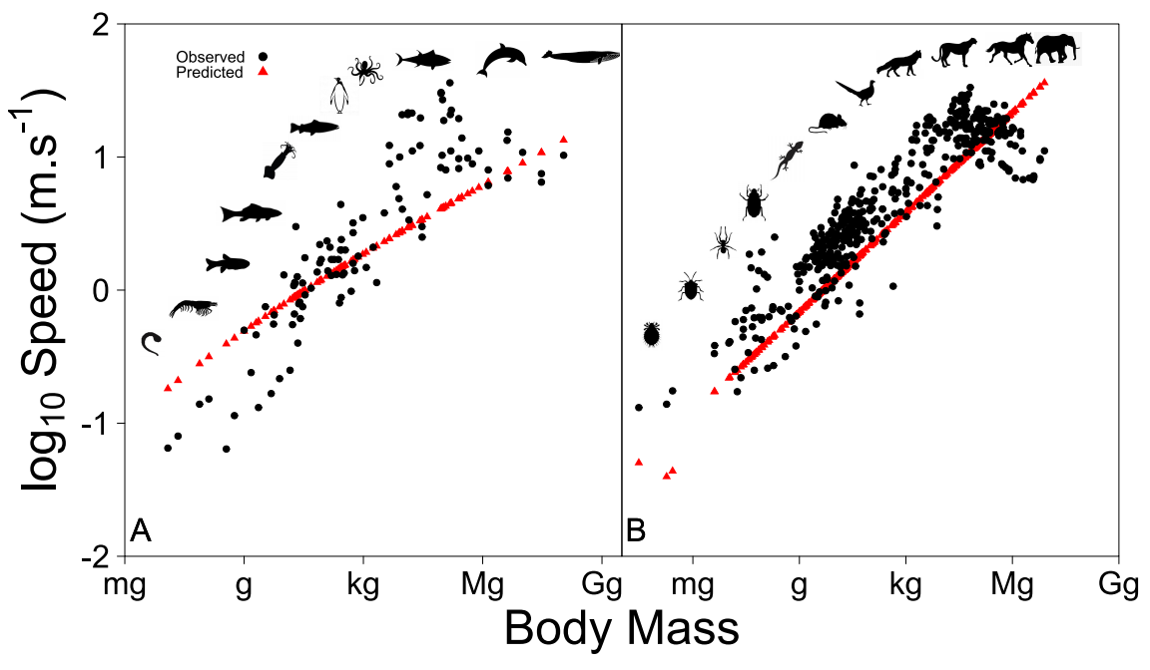**Figure 3**: Animal speed according to body size in aquatic (A) and terrestrial systems (B). Data shows that larger exhibit a lower speed compared to their size. Since the model does not include any specific mechanisms to account for this feature, predicted speed is overestimated for large predators. However, this involves only very large predators. The model is accurate for most predator sizes. 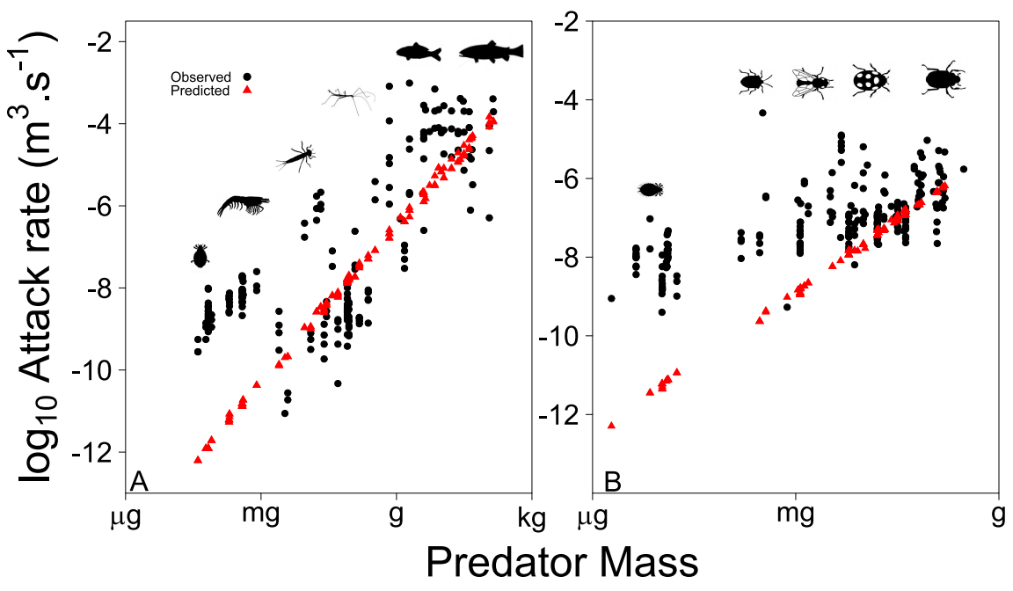**Figure 4**: Predator attack rate according to predator mass in aquatic (A) and terrestrial systems (B). The model fits data quite well, especially in aquatic systems. However, data shows variance. Moreover, other factors not related to size may affect attack rate (e.g., predator behavior).

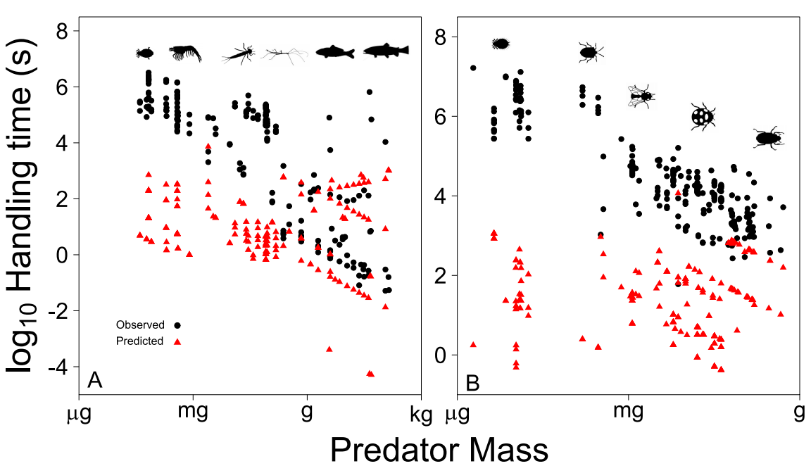

**Figure 5**: Handling time according to predator mass in aquatic (A) and terrestrial systems (B). The model is consistent with data in aquatic systems, but tends to underestimate handling time in terrestrial systems. Data shows variance. Moreover, other factors not related to size may increase handling time (e.g., prey defense).